SQL Server Integration Services

# Module 03 – Lab 01: Projects vs Packages

1. Launch Visual Studio 2019.
2. Select “Create a new project”.
3. From previous lab now you should have a recent used project template for Integration Services.
4. Select the project template and click create.

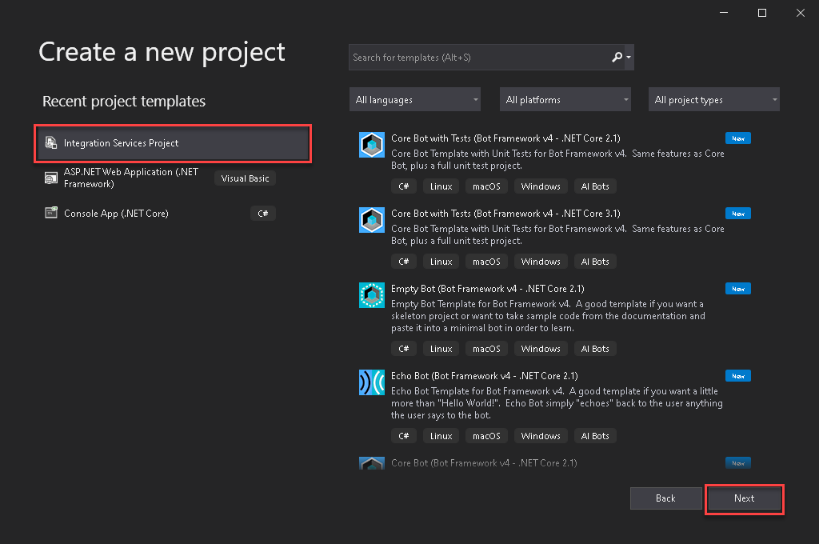

1. In next dialog box define the project name, Mod03Lab01 and click Create.
2. Once in the SSIS designer. Let’s set up a connection manager to our database. In the bottom center pain under Connection Manger, right-click select New Ole-DB Connection.  
   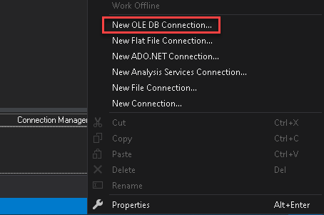
3. In Configure OLE DB Connect Manager, click New. (Note you might have an existing connection from previous lab you can leverage. If it exists selects the connection and click OK).  
   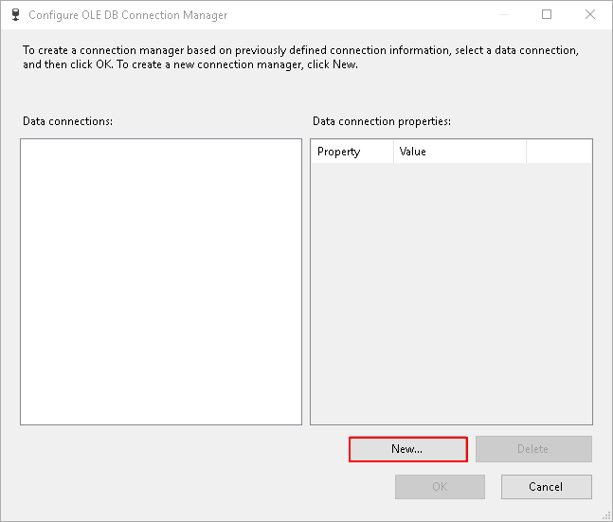
4. In connection manager, type the server’s name, select the database “AdventureWorks” and click OK.  
   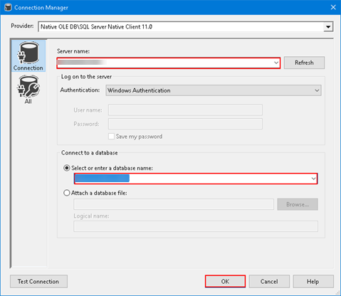
5. Click OK in Configure OLE DB Connection Manager. A new connection is added under Connection Manager.  
   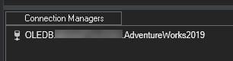  
     
   *Hint: Rename the connection manager to OLEDB.ServerName.DatabaseName. This will make it easier to identify which driver is being used for the connection.*
6. Create a new task, Execute SQL Task.

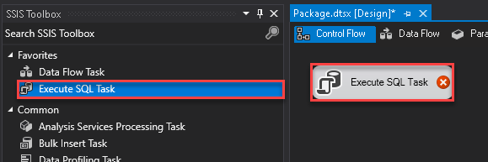

1. The red x, alert shows we are missing configuration. Double-click on the task to finish the configuration.
2. Configuration items required are **Connection** and **SQLStatement**. Click on the drop-down by connections, notice the connection we created in step #7 is present. So select OLEDB.*ServerName*.AdventureWorks.
3. In the SQL Statement enter “SELECT @@ServerName” and click OK.

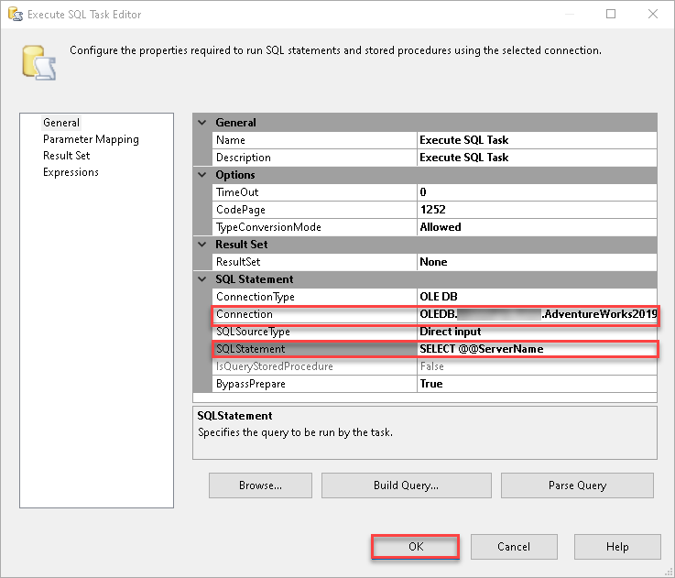

1. Execute package to confirm no issues, you should get executed successfully with green checkbox. Explore the progress report. Click on red stop button to go back to development.
2. Add a second package to the project. Right click on SSIS Packages > New SSIS Package. This should create a new package like below.  
   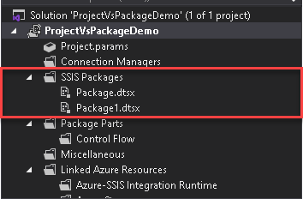
3. Create a task again, Execute SQL Task.



1. Like before an alert is raised because of missing configuration. Double-click to configure Connection and SQLStatement.
2. However, when you click on the drop-down, note the connection created earlier is not present.  
   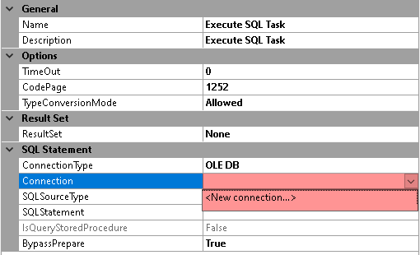
3. The connection created in step #7, was created as a package connection, and is scoped to that package only. What we need is a project connection. Instead of creating a new connection, we will reuse it from the first package. Click cancel in “Execute SQL Task Editor” dialog box.
4. Go to the first package. Right-click on connection OLEDB.Servername.DatabaseName and select Convert to Project Connection.

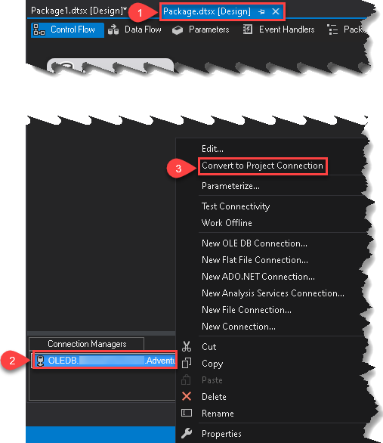

1. Note the connection name has (Project) in front of it and shows up under Connection Manager under Solution Explorer.

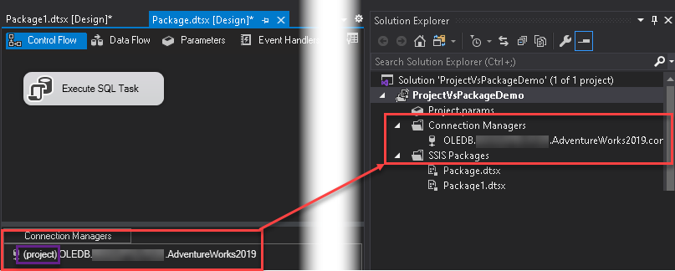

1. Let’s go back to second package and finish our task configuration. Configure the connection and the SQL Statement “SELECT @@ServerName”.



1. Test the package and review the progress.
2. After completing close Visual Studio saving the project.